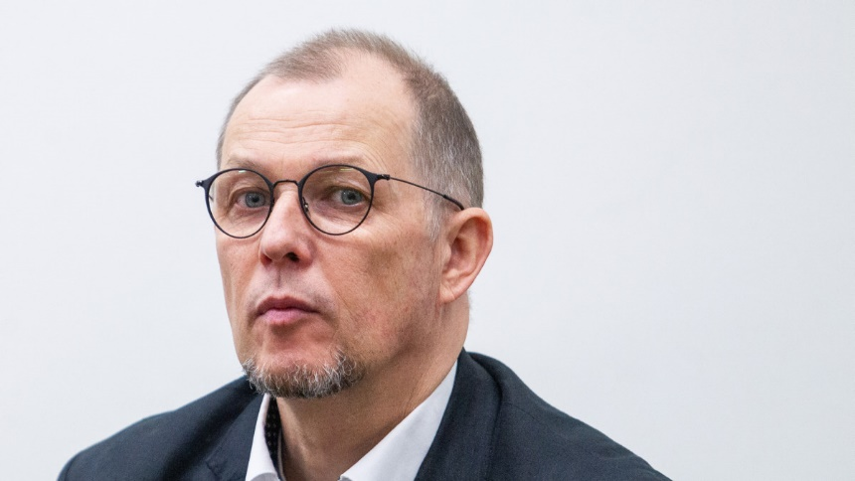**INTERVIEW WITH A WRITER**

**VYTAUTAS V. LANDSBERGIS**

*2022 09 22*

*Lithuania*

**How did you first get interested in writing?**

I've always been a voracious reader and have always loved the power of words to transport me to other worlds and experiences. I think that sparked my interest in writing, and as I got older and started to develop my own thoughts and ideas, I found that writing was a natural outlet for me to express myself and explore my own creativity.

**Who are some of your favorite writers and how have they influenced your work?**

Some of my favorite writers include Jane Austen, Edgar Allan Poe, and J.K. Rowling. Austen's wit and social commentary have always inspired me to think critically about the world around me, while Poe's use of language and imagery has taught me the power of evocative, descriptive writing. Rowling's magical worlds and engaging character development have also had a big influence on my own writing, as I often strive to create immersive, imaginative stories.

**What's your writing process like?**

Do you have any particular habits or routines that help you get into a creative state of mind?

I usually start by brainstorming ideas and jotting down notes and outlines. From there, I like to set aside dedicated writing time each day, during which I'll work on fleshing out my ideas and shaping them into a cohesive narrative. I also find it helpful to take breaks and step away from my work to clear my head and come back with fresh perspective. Exercise and music are also great ways for me to get into a creative state of mind.

**How do you come up with ideas for your stories? Do you have any particular sources of inspiration?**

I find inspiration all around me – in the news, in conversations with friends and family, in my own personal experiences and observations. I also like to challenge myself by setting constraints or prompts for my writing, as this can often lead to creative solutions and unique ideas. For example, I might try to write a story using only dialogue, or set in a specific location or time period.

**What's the most challenging part of the writing process for you?**

For me, the most challenging part of the writing process is often finding the time and discipline to sit down and write consistently. It can be tough to carve out dedicated writing time when you have other responsibilities and commitments, but it's important to make it a priority. I also find that the editing and revising stage can be challenging, as it requires a lot of critical thinking and attention to detail.

What do you hope readers will take away from your work?

I hope that readers will be entertained by my stories and find something relatable or meaningful in them. I also hope to inspire thought and discussion through my writing, and to encourage readers to consider different perspectives and ideas.

**What advice do you have for aspiring writers?**

My advice for aspiring writers is to read as much as you can, in a variety of genres and styles. This will help you to develop your own writing voice and understand what works (and what doesn't) in different types of writing. It's also important to write regularly, even if it's just for fun or practice. The more you write, the better you'll become at it. Finally, don't be afraid to seek feedback and revise your work – the editing and revising process is an essential part of becoming a better writer.

**What is your latest book? What is it about?**

My latest book "Iš gyvenimo laumių" is about the relationship between parents. How it looks to children when their parents disagree, when they get drunk, when they don't look for a beautiful life together. Then a fairy witch appears and messes up and ruins everything.

**Which of your books would you recommend as a must-read?**

I would suggest everyone to read the books of Gendrutis Morkūnas. He is the best Lithuanian children's writer. Unfortunately, dead. His books are of special beauty. And from mine, I would suggest one, depending on what that person needs. For divorced parents children i recommend „Berniukas ir žuvėdros“. "Rudnosiuko istorijos", "Obuolių pasakos", "Briedis Eugenijus" are "nonsense" books, they are about joy, about fooling around, about living life to the fullest.

**Your father is a politician, what are your thoughts about it?**

Well, he is my father. I support him, I respect what he did for my country, we all do. But he's very simple at home - he likes to celebrate birthday, Christmas, or new year's eve with family and closest friends. He doesn't like that commotion around him, sometimes even thinks that he would be normal Lithuanian then a politician which is known for restoration of the country.